**Montgomery College**

**CMSC 203**

**Assignment 3 Design, Learning Experience, and Screen Shoots**

HIEU TRAN

CMSC 203

|  |  |  |  |  |  |
| --- | --- | --- | --- | --- | --- |
| Input text | Input Key | Encrypted (method1) | Encrypted (method2) | Decrypt (method1) | Decrypt (method2) |
| ABC DEF G | 4 | EFG$HIJ$K |  | ABC DEF G |  |
| INPUT TEXT TEST | 9 | RWY^])]N!])]N\] |  | INPUT TEXT TEST |  |
| FAILED INPUT} | 13 |  | *FAILED* |  | *encryption failed* |
| CORONA VIRUSS | NO |  | Q^ ^\P.%W!#"! |  | CORONA VIRUSS |
| HEALTHY AND HAPPY | LALA |  | TFMM I%!MOP!TB\Q% |  | HEALTHY AND HAPPY |

**Test Table.**

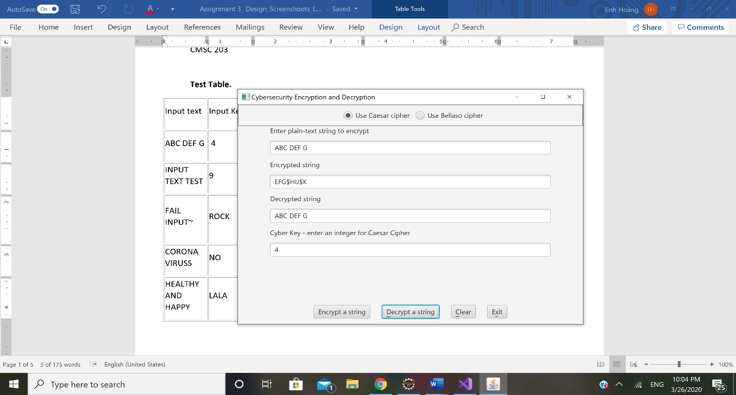

**UML Chart**

|  |
| --- |
| CryptoManager |
| -LOWER_BOUND: char  -UPPER_BOUND: char  -RANGE: char |
| +stringInBounds(plainText: String): boolean  +encryptCaesar(plainText: String, key: int): String  +encryptBellaso(plainText: String, bellasoStr: String): String  +decryptCaeser(encryptedText: String, key: int): String  +decryptBellaso(encryptedText: String, bellasoStr: String): String |

**LEARNING EXPERIENCE:**

I spent for hours and did not know why my codes were wrong, but then I realized that I did not cast char to int. In the future, I’ll better be careful with this issue.